Name: Wilfredo T. Pilapil Jr.

Year | Section: 3rd Year - BSIT

Date: May 15, 2024 – **Deadline will be today at 6:25 PM only.**

This must be the name of your word document – LASTNAME_INITIAL(APPDEV-MID) **TUNGUL_RD(APPDEV-MID)**

**(MIDTERM EXAM) APPLICATION DEVELOPMENT**

1. Create a Copy and Paste website content that can cater the audience need (i.e., copying the machine/devices text or files):

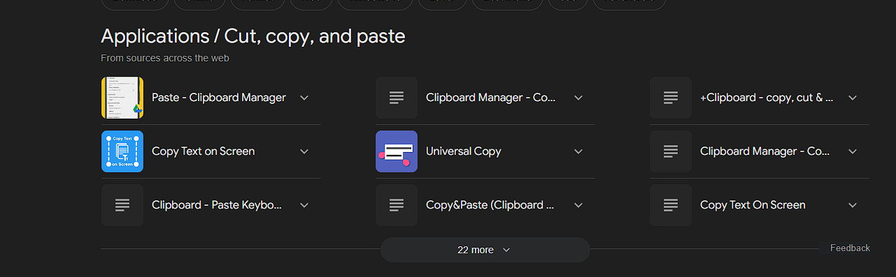

1. Upload your file via GitHub and named it as: username.github.io/appdev-midterm

[rdtungul.github.io/appdev-midterm/](https://rdtungul.github.io/appdev-midterm/)

1. Create your own sentence/wordings and replace all the Lorem ipsum text into your generated sentences (Note: images and icons are fixed). Add a metadata inside the head section. Please make sure that your design is 1:1, unique, and up to date:

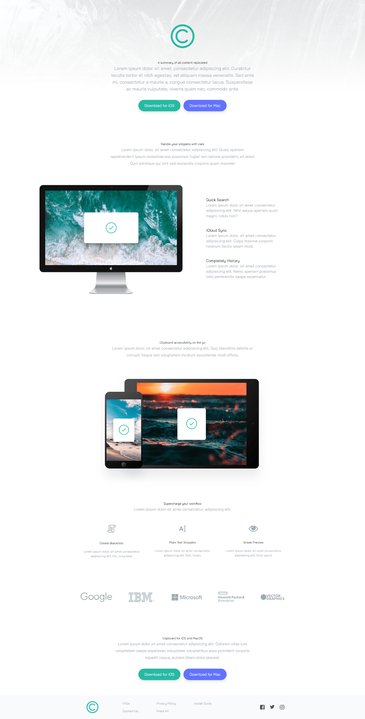

1. Make the site’s speed up to 98% on all aspects using Google PageSpeed Insights. (Note: Web layout only)

1. Network speed must be faster than the original speed. (Note: speed must be less than 2.5 seconds)

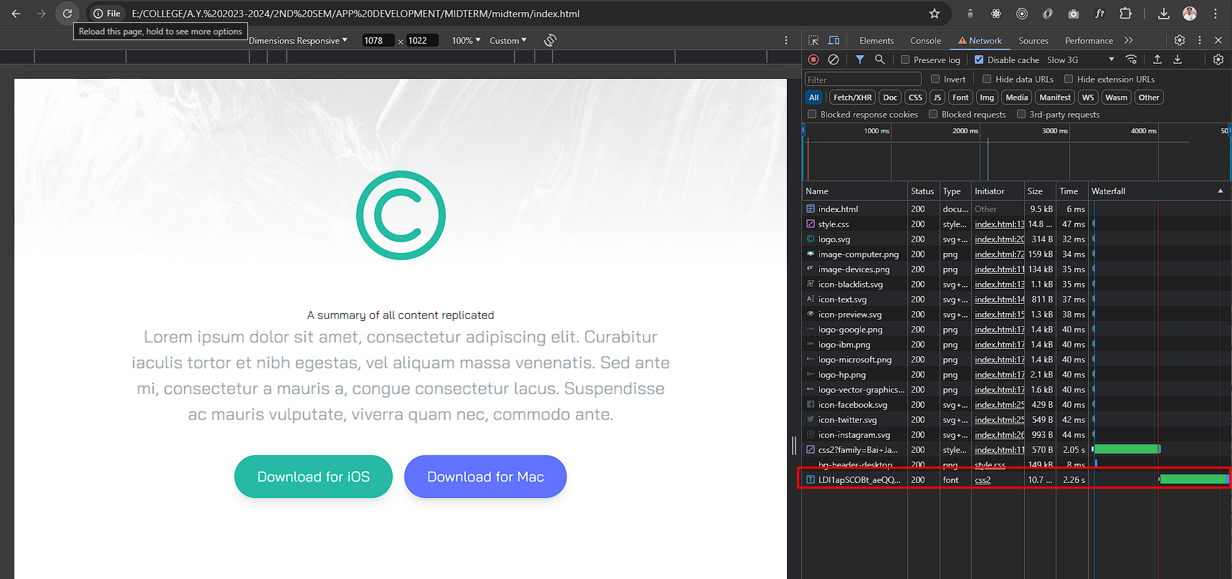

Save your screenshots here:

Save your code here:

<https://pagespeed.web.dev/analysis/https-saintlotuss-github-io-appdev-midterms/v9b108viaw?form_factor=desktop>

index.html

<!DOCTYPE html>

<html lang="en">

  <head>

    <!-- Meta here -->

    <meta charset="UTF-8">

    <meta name="viewport" content="width=device-width, initial-scale=1.0 Author: Wilfredo T. Pilapil Jr., Website: Content Replicated,">

    <meta name="description" content="a one-stop platform for all your content replication needs. We help you deliver content faster, more reliably, and at a wider scale."/>

    <!-- google fonts -->

    <link rel="preconnect" href="https://fonts.googleapis.com" />

    <link rel="preconnect" href="https://fonts.gstatic.com" crossorigin />

    <link

      href="https://fonts.googleapis.com/css2?family=Bai+Jamjuree:wght@400;600&display=swap"

      rel="stylesheet"

    />

    <link rel="stylesheet" href="css/style.css" />

    <title>Copy Clipboard (Midterm Exam)</title>

  </head>

  <body>

    <!-- Hero Section -->

    <section id="hero">

      < ="pt-16 mb-40 section-container">

        <img src="images/logo.min.svg" alt="" class="mx-auto my-16" />

        <h1><b>A summary of all content replicated</b></h1>

        <p class="mb-10 text-2xl section-content">

          To ensure a complete understanding of the replicated data, the researchers created a summary of all content replicated across the different servers.

        </p>

        <!-- Button Container -->

        <div class="button-container">

          <a

            href="#" target="_blank" role="button" aria-label="Just a button" style="color: black;"

            class="p-4 px-9 duration-300 rounded-full shadow-lg bg-strongCyan hover:opacity-100 "

          >

            <b>Download for iOS</b>

          </a>

          <a

            href="#" target="_blank" role="button" aria-label="Just a button"

            class="p-4 px-9 duration-300 rounded-full shadow-lg bg-lightBlue hover:opacity-100"

          >

            <b>Download for Mac</b>

          </a>

        </div>

      </div>

    </section>

    <!-- Snippets Section -->

    <section id="snippets">

      <div class="my-20 section-container">

        <h2><b>Handle your snippets with care</b></h2>

        <p class="mb-24 text-xl section-content">

          Don't underestimate the importance of handling your information snippets with care.

        These seemingly insignificant fragments can hold the key to unlocking a deeper understanding later,

        or they might contain sensitive details that require extra protection.

        </p>

      </div>

    </section>

    <!-- Features Section -->

    <section id="features">

      <div class="my-20 section-container">

        <div class="relative flex flex-col md:flex-row md:space-x-32">

          <!-- Image -->

          <div class="md:w-1/2">

            <img

              src="./images/image-computer.min.png"

              alt=""

              class="md:absolute top-0 right-[50%]"

            />

          </div>

          <!-- Items Container -->

          <div

            class="flex flex-col mt-16 mb-24 space-y-12 text-xl md:w-1/2 md:mb-60 md:text-left md:pl-16"

          >

            <!-- Item 1 -->

            <div>

              <p>Quick Search</p>

              <p class="max-w-md text-grayishBlue">

                Our website features a powerful quick search bar that lets you instantly find the information you need, whether it's product details, troubleshooting guides, or helpful articles.

              </p>

            </div>

            <!-- Item 2 -->

            <div>

              <p>iCloud Sync</p>

              <p class="max-w-md text-grayishBlue">

                With iCloud sync enabled, any changes you make to your photos, contacts, calendars, or other data on one Apple device will automatically be transferred and updated on all your other Apple devices,

              </p>

            </div>

            <!-- Item 3 -->

            <div>

              <p>Completely History</p>

              <p class="max-w-md text-grayishBlue">

                This website could feature articles, timelines, infographics, and even user-submitted memories of these "completely history" trends

              </p>

            </div>

          </div>

        </div>

      </div>

    </section>

    <!-- Access Anywhere Section -->

    <section id="access">

      <div class="my-20 section-container">

        <h3><b>Clipboard accessibility on the go</b></h3>

        <p class="mb-24 text-xl section-content">

          The clipboard is a temporary storage location on your device that holds copied text, images, files, or other data snippets.

        </p>

        <img src="./images/image-devices.min.png" alt="" class="mx-auto" />

      </div>

    </section>

    <!-- Supercharge Section -->

    <section id="supercharge">

      <div class="my-20 section-container">

        <h4><b>Supercharge your workflow</b></h4>

        <p class="mb-16 text-xl section-content">

          Imagine yourself as a productivity shinobi or ninja, effortlessly gliding through your tasks. No more feeling overwhelmed or drowning in deadlines.

        </p>

        <!-- Items Container -->

        <div

          class="flex flex-col items-center justify-between space-y-16 md:flex-row md:space-y-0 md:space-x-12"

        >

          <!-- Item 1 -->

          <div class="flex flex-col items-center space-y-5">

            <img src="images/icon-blacklist.min.svg" alt="" class="mb-6" />

            <p>Create Blacklists</p>

            <p class="max-w-md text-grayishBlue">

              creating a blacklist is a valuable tool for managing access and controlling unwanted content.  However, careful consideration is needed to ensure its effectiveness and avoid unintended consequences.

            </p>

          </div>

          <!-- Item 2 -->

          <div class="flex flex-col items-center space-y-5">

            <img src="images/icon-text.min.svg" alt="" class="mb-6" />

            <p>Plain Text Snippets</p>

            <p class="max-w-md text-grayishBlue">

              Plain Text Snippets offer a simple and versatile way to store and manage small pieces of information. Their accessibility and security make them a valuable tool

            </p>

          </div>

          <!-- Item 3 -->

          <div class="flex flex-col items-center space-y-5">

            <img src="images/icon-preview.min.svg" alt="" class="mb-6" />

            <p>Sneak Preview</p>

            <p class="max-w-md text-grayishBlue">

              providing a curated selection of high-quality websites and encouraging user interaction, this website can become a hub for content discovery and online inspiration.

            </p>

          </div>

        </div>

      </div>

    </section>

    <!-- References Section -->

    <section id="references">

      <div

        class="flex flex-col items-center justify-between max-w-6xl px-10 mx-auto space-y-16 my-44 md:flex-row md:space-y-0"

      >

        <img src="./images/logo-google.min.png" alt="" />

        <img src="./images/logo-ibm.min.png" alt="" />

        <img src="./images/logo-microsoft.min.png" alt="" />

        <img src="./images/logo-hp.min.png" alt="" />

        <img src="./images/logo-vector-graphics.min.png" alt="" />

      </div>

    </section>

    <!-- Bottom CTA Section -->

    <section id="bottom">

      <div class="my-20 section-container">

        <h5><b>Clipboard for iOS and MacOS</b></h5>

        <p class="mb-10 text-xl section-content">

          Content copied! But remember, originality is key! Use this as a springboard for your own ideas. Don't be afraid to put your unique spin on it, add your own experiences, and let your creativity flow!

        </p>

        <!-- Button Container -->

        <div class="button-container">

          <a

            href="#" target="_blank" role="button" aria-label="Just a button" style="color: black;"

            class="p-4 px-9 duration-300 rounded-full shadow-lg bg-strongCyan hover:opacity-100"

          >

            <b>Download for iOS</b>

          </a>

          <a

            href="#" target="_blank" role="button" aria-label="just a button"

            class="p-4 px-9 duration-300 rounded-full shadow-lg bg-lightBlue hover:opacity-100"

          >

            <b>Download for Mac</b>

          </a>

        </div>

      </div>

    </section>

    <footer class="bg-stronggray-50">

      <div class="section-container">

        <div class="flex flex-col items-center justify-between md:flex-row">

          <!-- Image -->

          <img src="images/logo.min.svg" alt="" class="scale-50" />

          <!-- Container for Menus & Social -->

          <div

            class="flex flex-col items-center justify-between flex-1 mb-10 space-y-6 md:flex-row md:mb-0 md:space-y-0 text-stronggrayishBlue"

          >

            <!-- Menus -->

            <div

              class="flex flex-col space-y-4 md:flex-row md:ml-24 md:space-x-24 md:space-y-0"

            >

              <!-- Menu 1 -->

              <div class="flex flex-col space-y-4 text-center md:text-left">

                <div><a href="#" class="hover:text-strongCyan">FAQs</a></div>

                <div>

                  <a href="#" class="hover:text-strongCyan">Contact Us</a>

                </div>

              </div>

              <!-- Menu 2 -->

              <div class="flex flex-col space-y-4 text-center md:text-left">

                <div>

                  <a href="#" class="hover:text-strongCyan">Privacy Policy</a>

                </div>

                <div>

                  <a href="#" class="hover:text-strongCyan">Press Kit</a>

                </div>

              </div>

              <!-- Menu 3 -->

              <div class="flex flex-col space-y-4 text-center md:text-left">

                <div>

                  <a href="#" class="hover:text-strongCyan">Install Guide</a>

                </div>

              </div>

            </div>

            <!-- Social Icons -->

            <div class="flex justify-between w-32 py-1">

              <a href="https://www.facebook.com/zediliciouss?mibextid=LQQJ4d" target="_blank" role="button" aria-label="Facebook Account"

                ><img

                  src="images/icon-facebook.min.svg"

                  alt=""

                  class="duration-200 ficon"

              /></a>

              <a href="https://twitter.com/CircleIV_Greed" target="_blank" role="button" aria-label="Twitter/X account"

                ><img

                  src="images/icon-twitter.min.svg"

                  ar

                  alt=""

                  class="duration-200 ficon"

              /></a>

              <a href="https://www.instagram.com/definitelynotnior?igsh=bnBkOTE1enFpNDY0&utm_source=qr" target="_blank" role="button" aria-label="Instagram Account"

                ><img

                  src="images/icon-instagram.min.svg"

                  link

                  alt=""

                  class="duration-200 ficon"

              /></a>

            </div>

          </div>

        </div>

      </div>

    </footer>

  </body>

</html>

*** Warning: Duplicate design for the resume will be investigated and reviewed. ***

Goodluck and keep going! You can do it!

___________________

**Roseph Darl Tungul**

Instructor